Chapter 7, Solution 53.

(a) Before t = 0, 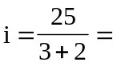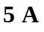
After t = 0, 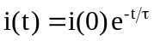
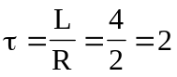, 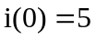
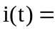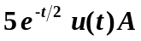

- Before t = 0, the inductor acts as a short circuit so that the 2  and 4 
resistors are short-circuited.
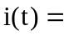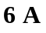
After t = 0, we have an RL circuit.
, 